**SPORTS SHOP MANAGEMENT SYSTEM**

|  |  |  |
| --- | --- | --- |
| **SR NO** | **NAME** | **PAGE NO** |
| **1** | **HTML** | **4** |
| **2** | **CSS** | **5** |
| **3** | **JS** | **27,28** |
| **4** | **XML** | **52** |
| **5** | **INSERTION** | **16** |
| **6** | **DELETION** | **47** |
| **7** | **SELECTION** | **17** |
| **8** | **UPDATE** | **47** |

|  |  |
| --- | --- |
| **NAME** | **ROLL NO** |
| **BALRAJ** | **20CE14** |
| **BRENDAN** | **20CE15** |

**Database**

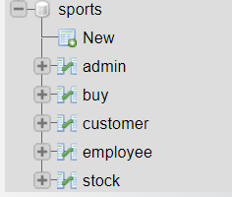

**Admin table**

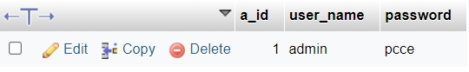

**Home.php**

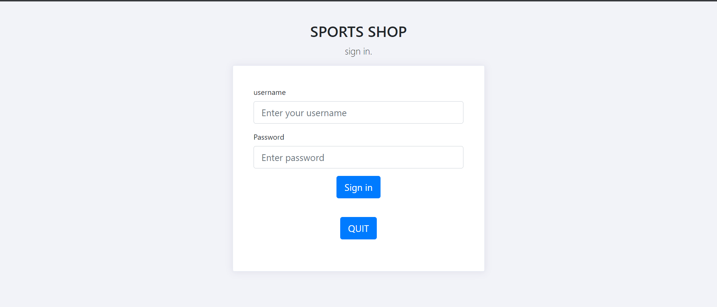

<?php

session_start();

$dbhost = "localhost";

$dbuser = "root";

$dbpass = "";

$dbname = "sports";

if(!$con = mysqli_connect($dbhost,$dbuser,$dbpass,$dbname))

{

die("failed to connect!");

}

include("connection.php");

if($_SERVER['REQUEST_METHOD'] == "POST")

{

//something was posted

$user_name = $_POST['user_name'];

$password = $_POST['password'];

if(!empty($user_name) && !empty($password) && !is_numeric($user_name))

{

//read from database

$query = "select * from admin ";

$result = mysqli_query($con, $query);

if($result)

{

if($result && mysqli_num_rows($result) > 0)

{

$user_data = mysqli_fetch_assoc($result);

if($user_data['password'] === $password)

{

header("Location: login.php");

die;

}

}

}

echo "wrong username or password!";

}else

{

echo "wrong username or password!";

}

}

?>

<!DOCTYPE html>

<html lang="en">

<head>

<meta charset="utf-8">

<title>Login</title>

<meta name="viewport" content="width=device-width, initial-scale=1">

<script src="https://code.jquery.com/jquery-1.10.2.min.js"></script>

<link href="https://cdn.jsdelivr.net/npm/bootstrap@4.1.1/dist/css/bootstrap.min.css" rel="stylesheet">

<script src="https://cdn.jsdelivr.net/npm/bootstrap@4.1.1/dist/js/bootstrap.bundle.min.js"></script>

</head>

<body>

<div class="container h-100">

<div class="row h-100">

<div class="col-sm-10 col-md-8 col-lg-6 mx-auto d-table h-100">

<div class="d-table-cell align-middle">

<div class="text-center mt-4">

<h1 class="h2">SPORTS SHOP</h1>

<p class="lead">

sign in.

</p>

</div>

<div class="card">

<div class="card-body">

<div class="m-sm-4">

<form method="post">

<div class="form-group">

<label>username</label>

<input class="form-control form-control-lg" type="text" name="user_name" placeholder="Enter your username">

</div>

<div class="form-group">

<label>Password</label>

<input class="form-control form-control-lg" type="password" name="password" placeholder="Enter password">

</div>

<div class="text-center mt-3">

<button type="submit" class="btn btn-lg btn-primary">Sign in</button> <br><br>

</div>

<div class="text-center mt-3">

<button type="button" class="btn btn-lg btn-primary" onclick="location.href='name.xml'">QUIT</button> <br><br>

</div>

</form>

</div>

</div>

</div>

</div>

</div>

</div>

</div>

<style type="text/css">

body{

margin-top:20px;

background-color: #f2f3f8;

}

.card {

margin-bottom: 1.5rem;

box-shadow: 0 1px 15px 1px rgba(52,40,104,.08);

}

.card {

position: relative;

display: -ms-flexbox;

display: flex;

-ms-flex-direction: column;

flex-direction: column;

min-width: 0;

word-wrap: break-word;

background-color: #fff;

background-clip: border-box;

border: 1px solid #e5e9f2;

border-radius: .2rem;

}

</style>

<script type="text/javascript">

</script>

</body>

</html>

**Login.php**



<?php

session_start();

$dbhost = "localhost";

$dbuser = "root";

$dbpass = "";

$dbname = "sports";

if(!$con = mysqli_connect($dbhost,$dbuser,$dbpass,$dbname))

{

die("failed to connect!");

}

?>

<!DOCTYPE html>

<html>

<head>

<title>home</title>

<meta charset="utf-8">

<title>home</title>

<meta name="viewport" content="width=device-width, initial-scale=1">

<script src="https://code.jquery.com/jquery-1.10.2.min.js"></script>

<link href="https://cdn.jsdelivr.net/npm/bootstrap@4.1.1/dist/css/bootstrap.min.css" rel="stylesheet">

<script src="https://cdn.jsdelivr.net/npm/bootstrap@4.1.1/dist/js/bootstrap.bundle.min.js"></script>

</head>

<body>

<div class="text-center mt-3">

<button type="button" class="btn btn-lg btn-primary" onclick="location.href='logout.php'">logout</button> <br><br>

</div>

<div class="container h-100">

<div class="row h-100">

<div class="col-sm-10 col-md-8 col-lg-6 mx-auto d-table h-100">

<div class="d-table-cell align-middle">

<div class="text-center mt-4">

<h1 class="h2">SPORTS SHOP</h1>

<br><br>

</div>

<div class="card">

<div class="card-body">

<div class="m-sm-4">

<form method="post">

<div class="text-center mt-3">

<button type="button" class="btn btn-lg btn-primary" onclick="location.href='employee.php'">EMPLOYEE</button> <br><br>

</div>

<div class="text-center mt-3">

<button type="button" class="btn btn-lg btn-primary" onclick="location.href='customer.php'">CUSTOMER</button> <br><br>

</div>

<div class="text-center mt-3">

<button type="button" class="btn btn-lg btn-primary" onclick="location.href='viewstock.php'">VIEW STOCK</button> <br><br>

</div>

</form>

</div>

</div>

</div>

</div>

</div>

</div>

</div>

<style type="text/css">

body{

/* background-image:url("Navigation.jpeg" ); */

margin-top:20px;

background-color: #f2f3f8; *

}

.card {

margin-bottom: 1.5rem;

box-shadow: 0 1px 15px 1px rgba(52,40,104,.08);

}

.card {

position: relative;

display: -ms-flexbox;

display: flex;

-ms-flex-direction: column;

flex-direction: column;

min-width: 0;

word-wrap: break-word;

background-color: #fff;

background-clip: border-box;

border: 1px solid #e5e9f2;

border-radius: .2rem;

}

</style>

<script type="text/javascript">

</script>

</body>

</html>

**Employee table**

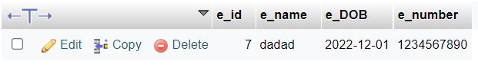

**Employee.php**

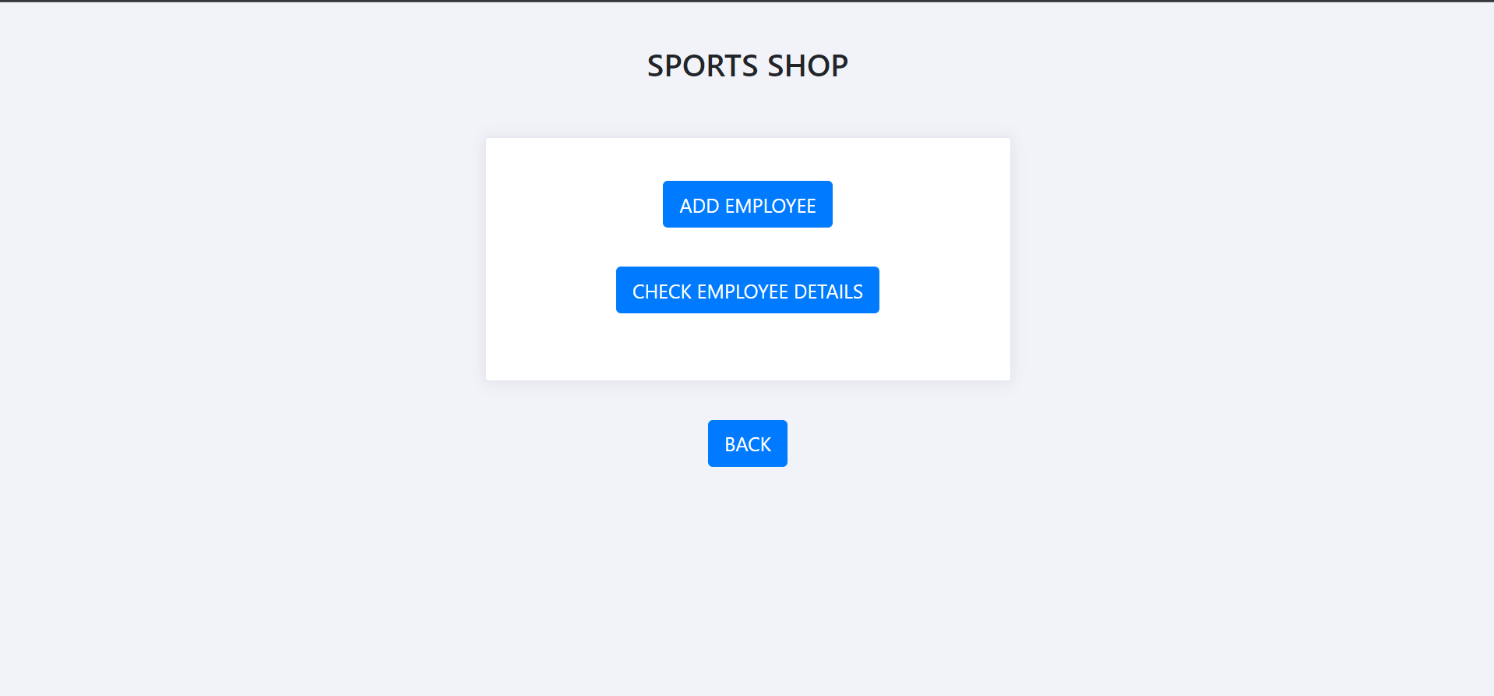

<?php

session_start();

$dbhost = "localhost";

$dbuser = "root";

$dbpass = "";

$dbname = "sports";

if(!$con = mysqli_connect($dbhost,$dbuser,$dbpass,$dbname))

{

die("failed to connect!");

}

?>

<!DOCTYPE html>

<html>

<head>

<title>home</title>

<meta charset="utf-8">

<title>home</title>

<meta name="viewport" content="width=device-width, initial-scale=1">

<script src="https://code.jquery.com/jquery-1.10.2.min.js"></script>

<link href="https://cdn.jsdelivr.net/npm/bootstrap@4.1.1/dist/css/bootstrap.min.css" rel="stylesheet">

<script src="https://cdn.jsdelivr.net/npm/bootstrap@4.1.1/dist/js/bootstrap.bundle.min.js"></script>

</head>

<body>

<div class="container h-100">

<div class="row h-100">

<div class="col-sm-10 col-md-8 col-lg-6 mx-auto d-table h-100">

<div class="d-table-cell align-middle">

<div class="text-center mt-4">

<h1 class="h2">SPORTS SHOP</h1>

<br><br>

</div>

<div class="card">

<div class="card-body">

<div class="m-sm-4">

<form method="post">

<div class="text-center mt-3">

<button type="button" class="btn btn-lg btn-primary" onclick="location.href='addemployee.php'">ADD EMPLOYEE</button> <br><br>

</div>

<div class="text-center mt-3">

<button type="button" class="btn btn-lg btn-primary" onclick="location.href='detailsemployee.php'">CHECK EMPLOYEE DETAILS</button> <br><br>

</div>

</form>

</div>

</div>

</div>

</div>

</div>

</div>

</div>

<div class="text-center mt-3">

<button type="button" class="btn btn-lg btn-primary" onclick="location.href='login.php'">BACK</button> <br><br>

</div>

<style type="text/css">

body{

margin-top:20px;

background-color: #f2f3f8;

}

.card {

margin-bottom: 1.5rem;

box-shadow: 0 1px 15px 1px rgba(52,40,104,.08);

}

.card {

position: relative;

display: -ms-flexbox;

display: flex;

-ms-flex-direction: column;

flex-direction: column;

min-width: 0;

word-wrap: break-word;

background-color: #fff;

background-clip: border-box;

border: 1px solid #e5e9f2;

border-radius: .2rem;

}

</style>

<script type="text/javascript">

</script>

</body>

</html>

Addemployee.php

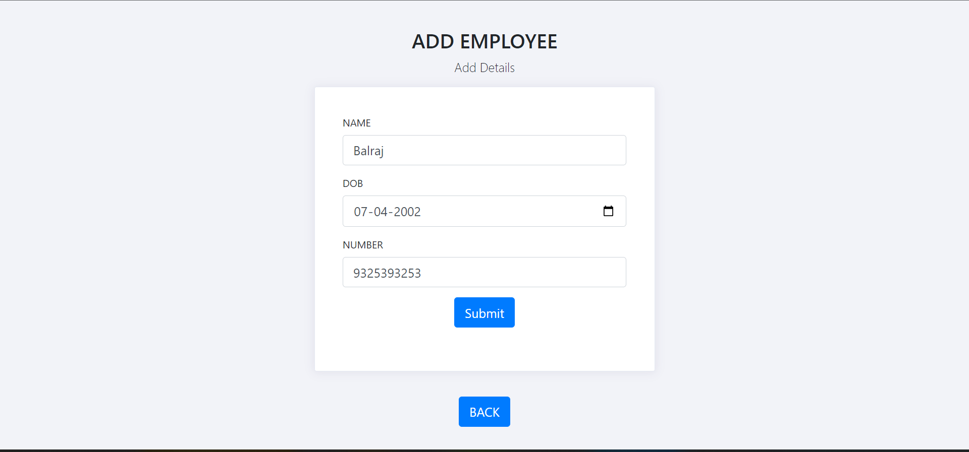

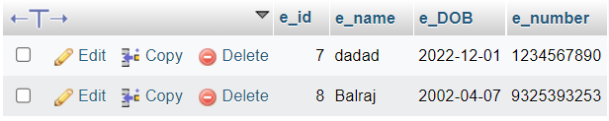

Html and css

<!DOCTYPE html>

<html lang="en">

<head>

<meta charset="utf-8">

<title>Registration</title>

<meta name="viewport" content="width=device-width, initial-scale=1">

<script src="https://code.jquery.com/jquery-1.10.2.min.js"></script>

<link href="https://cdn.jsdelivr.net/npm/bootstrap@4.1.1/dist/css/bootstrap.min.css" rel="stylesheet">

<script src="https://cdn.jsdelivr.net/npm/bootstrap@4.1.1/dist/js/bootstrap.bundle.min.js"></script>

</head>

<body>

<div class="container h-100">

<div class="row h-100">

<div class="col-sm-10 col-md-8 col-lg-6 mx-auto d-table h-100">

<div class="d-table-cell align-middle">

<div class="text-center mt-4">

<h1 class="h2">ADD EMPLOYEE</h1>

<p class="lead">

Add Details

</p>

</div>

<div class="card">

<div class="card-body">

<div class="m-sm-4">

<form action="addemployee1.php" method="post">

<div class="form-group">

<label>NAME</label>

<input class="form-control form-control-lg" type="text" name="e_name" placeholder="Enter name of employee">

</div>

<div class="form-group">

<label>DOB</label>

<input class="form-control form-control-lg" type="date" name="e_DOB" placeholder="Enter DOB">

</div>

<div class="form-group">

<label>NUMBER</label>

<input class="form-control form-control-lg" type="text" name="e_number" placeholder="Enter number of employee">

</div>

<div class="text-center mt-3">

<button type="submit" class="btn btn-lg btn-primary">Submit</button> <br><br>

</div>

</form>

</div>

</div>

</div>

</div>

</div>

</div>

</div>

<div class="text-center mt-3">

<button type="button" class="btn btn-lg btn-primary" onclick="location.href='employee.php'">BACK</button> <br><br>

</div>

<style type="text/css">

body{

margin-top:20px;

background-color: #f2f3f8;

}

.card {

margin-bottom: 1.5rem;

box-shadow: 0 1px 15px 1px rgba(52,40,104,.08);

}

.card {

position: relative;

display: -ms-flexbox;

display: flex;

-ms-flex-direction: column;

flex-direction: column;

min-width: 0;

word-wrap: break-word;

background-color: #fff;

background-clip: border-box;

border: 1px solid #e5e9f2;

border-radius: .2rem;

}

</style>

<script type="text/javascript">

</script>

</body>

</html>

Querry connection

<?php

session_start();

$dbhost = "localhost";

$dbuser = "root";

$dbpass = "";

$dbname = "sports";

if(!$con = mysqli_connect($dbhost,$dbuser,$dbpass,$dbname))

{

die("failed to connect!");

}

if($_SERVER['REQUEST_METHOD'] == "POST")

{

$e_name = $_POST['e_name'];

$e_DOB = $_POST['e_DOB'];

$e_number = $_POST['e_number'];

if(preg_match('/^[0-9]{10}+$/', $e_number))

{

echo "Valid Phone Number";

if(!empty($e_name) && !empty($e_DOB) && !empty($e_number) )

{

**$query = "insert into employee (e_name,e_DOB,e_number ) VALUES ('$e_name', '$e_DOB', '$e_number')";**

mysqli_query($con, $query);

}else

{

echo "Please enter some valid information!";

header("Location: employee.php");

}

mysqli_close($con);

header("Location: employee.php");

}

else

{

echo "Invalid Phone Number";

header("Location: validation2.php");

}

}

?>

**Detailemployee.php**

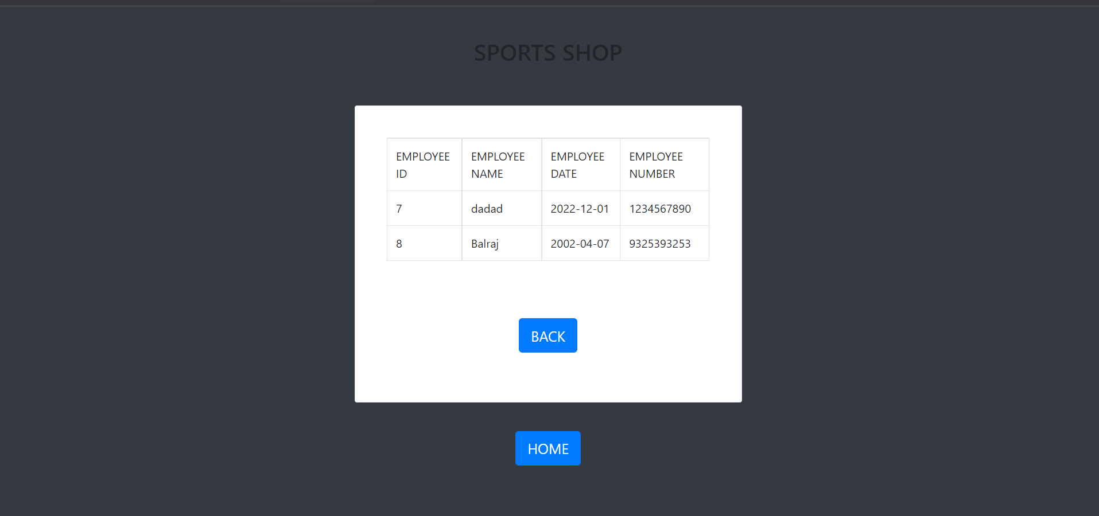

<?php

require_once("connection.php");

**$query = " select * from employee ";**

$result = mysqli_query($con,$query);

?>

<!DOCTYPE html>

<html lang="en">

<head>

<meta name="viewport" content="width=device-width, initial-scale=1">

<script src="https://code.jquery.com/jquery-1.10.2.min.js"></script>

<link href="https://cdn.jsdelivr.net/npm/bootstrap@4.1.1/dist/css/bootstrap.min.css" rel="stylesheet">

<script src="https://cdn.jsdelivr.net/npm/bootstrap@4.1.1/dist/js/bootstrap.bundle.min.js"></script>

</head>

<body class="bg-dark">

<div class="container h-100">

<div class="row h-100">

<div class="col-sm-10 col-md-8 col-lg-6 mx-auto d-table h-100">

<div class="d-table-cell align-middle">

<div class="text-center mt-4">

<h1 class="h2">SPORTS SHOP</h1>

<br><br>

</div>

<div class="card">

<div class="card-body">

<div class="m-sm-4">

<table class="table table-bordered">

<tr>

<td> EMPLOYEE ID </td>

<td> EMPLOYEE NAME</td>

<td> EMPLOYEE DATE </td>

<td> EMPLOYEE NUMBER </td>

</tr>

<?php

while($row=mysqli_fetch_assoc($result))

{

$e_id = $row['e_id'];

$e_name = $row['e_name'];

$e_DOB = $row['e_DOB'];

$e_number = $row['e_number'];

?>

<tr>

<td><?php echo $e_id ?></td>

<td><?php echo $e_name ?></td>

<td><?php echo $e_DOB ?></td>

<td><?php echo $e_number ?></td>

</tr>

<?php

}

?>

</table>

<br><br>

<div class="text-center mt-3">

<button type="button" class="btn btn-lg btn-primary" onclick="location.href='employee.php'">BACK</button> <br><br>

</div>

</div>

</div>

</div>

</div>

</div>

</div>

</div>

<div class="text-center mt-3">

<button type="button" class="btn btn-lg btn-primary" onclick="location.href='login.php'">HOME</button> <br><br>

</div>

<style type="text/css">

body{

margin-top:20px;

background-color: #f2f3f8;

}

.card {

margin-bottom: 1.5rem;

box-shadow: 0 1px 15px 1px rgba(52,40,104,.08);

}

.card {

position: relative;

display: -ms-flexbox;

display: flex;

-ms-flex-direction: column;

flex-direction: column;

min-width: 0;

word-wrap: break-word;

background-color: #fff;

background-clip: border-box;

border: 1px solid #e5e9f2;

border-radius: .2rem;

}

</style>

<script type="text/javascript">

</script>

</body>

</html>

**Customer.php**

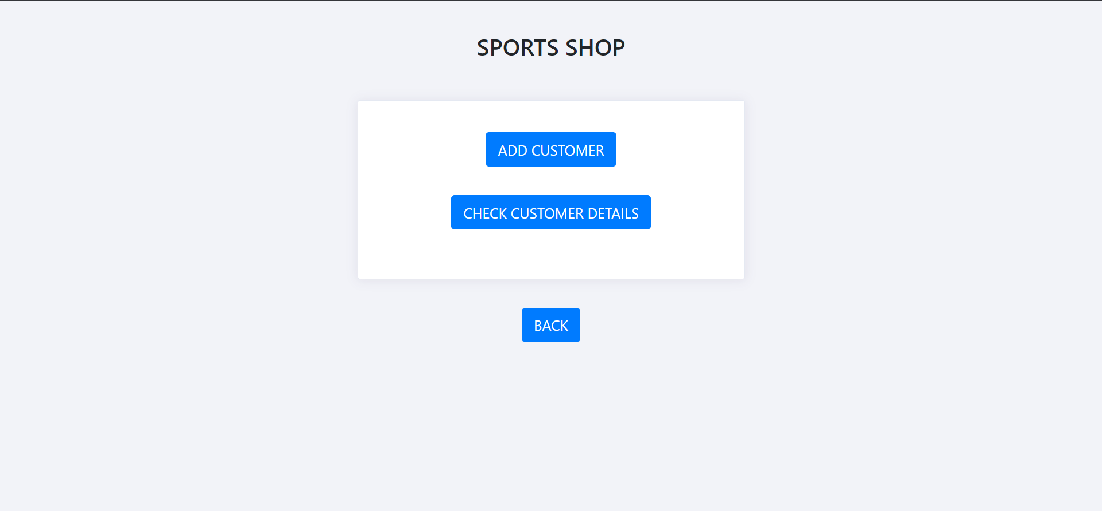

<?php

session_start();

$dbhost = "localhost";

$dbuser = "root";

$dbpass = "";

$dbname = "sports";

if(!$con = mysqli_connect($dbhost,$dbuser,$dbpass,$dbname))

{

die("failed to connect!");

}

?>

<!DOCTYPE html>

<html>

<head>

<title>home</title>

<meta charset="utf-8">

<title>home</title>

<meta name="viewport" content="width=device-width, initial-scale=1">

<script src="https://code.jquery.com/jquery-1.10.2.min.js"></script>

<link href="https://cdn.jsdelivr.net/npm/bootstrap@4.1.1/dist/css/bootstrap.min.css" rel="stylesheet">

<script src="https://cdn.jsdelivr.net/npm/bootstrap@4.1.1/dist/js/bootstrap.bundle.min.js"></script>

</head>

<body>

<div class="container h-100">

<div class="row h-100">

<div class="col-sm-10 col-md-8 col-lg-6 mx-auto d-table h-100">

<div class="d-table-cell align-middle">

<div class="text-center mt-4">

<h1 class="h2">SPORTS SHOP</h1>

<br><br>

</div>

<div class="card">

<div class="card-body">

<div class="m-sm-4">

<form method="post">

<div class="text-center mt-3">

<button type="button" class="btn btn-lg btn-primary" onclick="location.href='addcustomer.php'">ADD CUSTOMER</button> <br><br>

</div>

<div class="text-center mt-3">

<button type="button" class="btn btn-lg btn-primary" onclick="location.href='detailscustomer.php'">CHECK CUSTOMER DETAILS</button> <br><br>

</div>

</form>

</div>

</div>

</div>

</div>

</div>

</div>

</div>

<div class="text-center mt-3">

<button type="button" class="btn btn-lg btn-primary" onclick="location.href='login.php'">BACK</button> <br><br>

</div>

<style type="text/css">

body{

margin-top:20px;

background-color: #f2f3f8;

}

.card {

margin-bottom: 1.5rem;

box-shadow: 0 1px 15px 1px rgba(52,40,104,.08);

}

.card {

position: relative;

display: -ms-flexbox;

display: flex;

-ms-flex-direction: column;

flex-direction: column;

min-width: 0;

word-wrap: break-word;

background-color: #fff;

background-clip: border-box;

border: 1px solid #e5e9f2;

border-radius: .2rem;

}

</style>

<script type="text/javascript">

**</script>**

</body>

</html>

**Customer table**

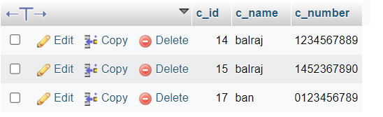

**Addcustomer.php**

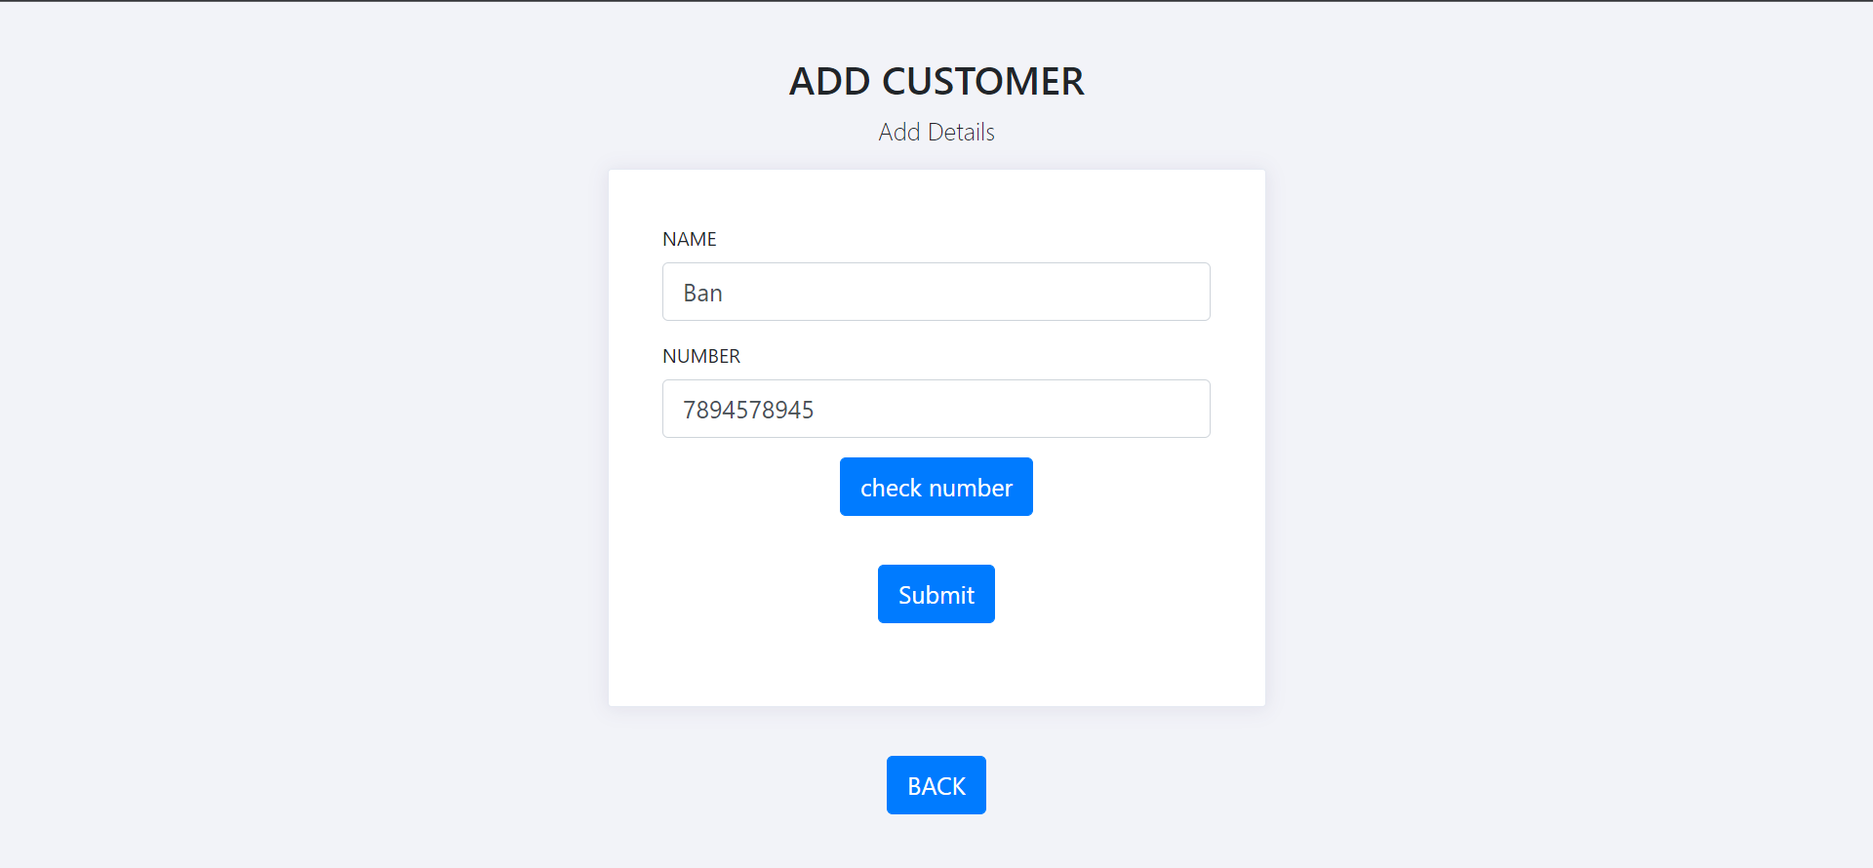

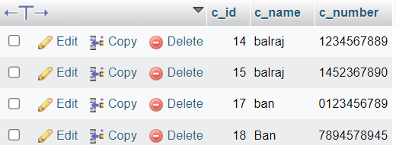

Html and css

<!DOCTYPE html>

<html lang="en">

<head>

<meta charset="utf-8">

<title>Registration</title>

<meta name="viewport" content="width=device-width, initial-scale=1">

<script src="https://code.jquery.com/jquery-1.10.2.min.js"></script>

<link href="https://cdn.jsdelivr.net/npm/bootstrap@4.1.1/dist/css/bootstrap.min.css" rel="stylesheet">

<script src="https://cdn.jsdelivr.net/npm/bootstrap@4.1.1/dist/js/bootstrap.bundle.min.js"></script>

</head>

<body>

<div class="container h-100">

<div class="row h-100">

<div class="col-sm-10 col-md-8 col-lg-6 mx-auto d-table h-100">

<div class="d-table-cell align-middle">

<div class="text-center mt-4">

<h1 class="h2">ADD CUSTOMER</h1>

<p class="lead">

Add Details

</p>

</div>

<div class="card">

<div class="card-body">

<div class="m-sm-4">

<form action="addcustomer1.php" method="post">

<div class="form-group">

<label>NAME</label>

<input class="form-control form-control-lg" type="text" name="c_name" placeholder="Enter name of customer">

</div>

<div class="form-group">

<label>NUMBER</label>

<input class="form-control form-control-lg" type="text" name="c_number" placeholder="Enter number of customer">

</div>

<div class="text-center mt-3">

<button type="button" class="btn btn-lg btn-primary" onclick="location.href='test.html'">check number</button> <br><br>

</div>

<div class="text-center mt-3">

<button type="submit" class="btn btn-lg btn-primary">Submit</button> <br><br>

</div>

</form>

</div>

</div>

</div>

</div>

</div>

</div>

</div>

<div class="text-center mt-3">

<button type="button" class="btn btn-lg btn-primary" onclick="location.href='customer.php'">BACK</button> <br><br>

</div>

<style type="text/css">

body{

margin-top:20px;

background-color: #f2f3f8;

}

.card {

margin-bottom: 1.5rem;

box-shadow: 0 1px 15px 1px rgba(52,40,104,.08);

}

.card {

position: relative;

display: -ms-flexbox;

display: flex;

-ms-flex-direction: column;

flex-direction: column;

min-width: 0;

word-wrap: break-word;

background-color: #fff;

background-clip: border-box;

border: 1px solid #e5e9f2;

border-radius: .2rem;

}

</style>

<script type="text/javascript">

</script>

</body>

</html>

Querry connection

<?php

session_start();

$dbhost = "localhost";

$dbuser = "root";

$dbpass = "";

$dbname = "sports";

if(!$con = mysqli_connect($dbhost,$dbuser,$dbpass,$dbname))

{

die("failed to connect!");

}

if($_SERVER['REQUEST_METHOD'] == "POST")

{

$c_name = $_POST['c_name'];

$c_number = $_POST['c_number'];

if(preg_match('/^[0-9]{10}+$/', $c_number))

{

echo "Valid Phone Number";

if(!empty($c_name) && !empty($c_number) )

{

$query = "insert into customer (c_name,c_number ) VALUES ('$c_name', '$c_number')";

mysqli_query($con, $query);

}else

{

echo "Please enter some valid information!";

header("Location: customer.php");

}

mysqli_close($con);

header("Location: customer.php");

} else

{

echo "Invalid Phone Number";

header("Location: validation1.php");

}

}

?>

**Check number[javascript]**

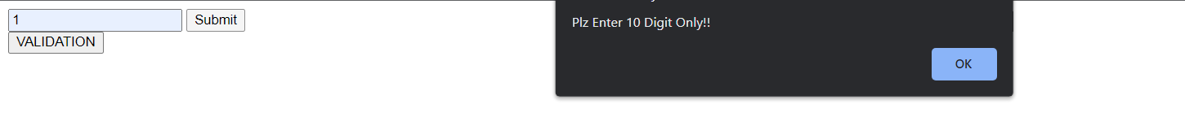

<!DOCTYPE html>

<html>

<head>

<title>

Mobile Number Validation

</title>

</head>

<body>

<form>

<input type="text" placeholder="Enter Mobile Number" id="pnum" required>

<input type="submit" name="submit" value="Submit" onclick="valid()">

<div class="text-center mt-3">

<button type="button" class="btn btn-lg btn-primary" onclick="location.href='addcustomer.php'">VALIDATION</button> <br><br>

</div>

</form>

<script>

function valid()

{

var p=/^\d{10}$/;

var val=document.getElementById('pnum');

if(val.value.length!=10){

alert("Plz Enter 10 Digit Only!!");

}

else{

if(val.value.match(p)){

alert("VALID NUMBER");

}

else{

alert("Wrong format");

}

}

}

</script>

</body>

</html>

**Detailscustomer.php**

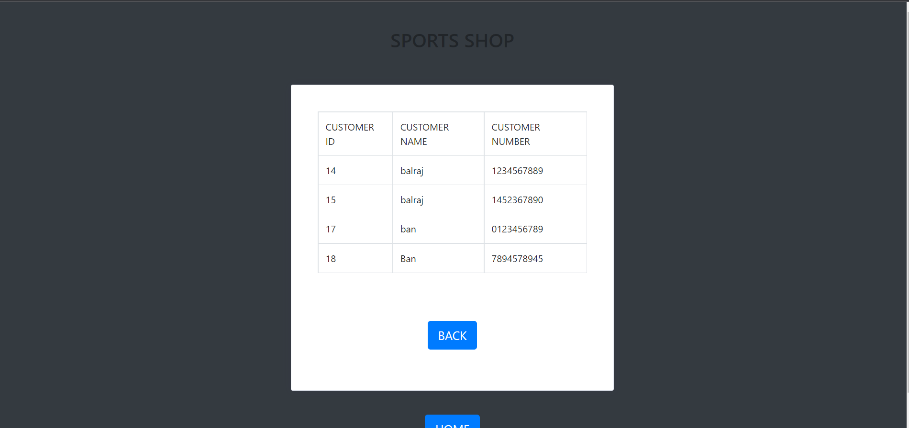

<?php

require_once("connection.php");

$query = " select * from customer ";

$result = mysqli_query($con,$query);

?>

<!DOCTYPE html>

<html lang="en">

<head>

<meta name="viewport" content="width=device-width, initial-scale=1">

<script src="https://code.jquery.com/jquery-1.10.2.min.js"></script>

<link href="https://cdn.jsdelivr.net/npm/bootstrap@4.1.1/dist/css/bootstrap.min.css" rel="stylesheet">

<script src="https://cdn.jsdelivr.net/npm/bootstrap@4.1.1/dist/js/bootstrap.bundle.min.js"></script>

</head>

<body class="bg-dark">

<div class="container h-100">

<div class="row h-100">

<div class="col-sm-10 col-md-8 col-lg-6 mx-auto d-table h-100">

<div class="d-table-cell align-middle">

<div class="text-center mt-4">

<h1 class="h2">SPORTS SHOP</h1>

<br><br>

</div>

<div class="card">

<div class="card-body">

<div class="m-sm-4">

<table class="table table-bordered">

<tr>

<td> CUSTOMER ID </td>

<td> CUSTOMER NAME</td>

<td> CUSTOMER NUMBER </td>

</tr>

<?php

while($row=mysqli_fetch_assoc($result))

{

$c_id = $row['c_id'];

$c_name = $row['c_name'];

$c_number = $row['c_number'];

?>

<tr>

<td><?php echo $c_id ?></td>

<td><?php echo $c_name ?></td>

<td><?php echo $c_number ?></td>

</tr>

<?php

}

?>

</table>

<br><br>

<div class="text-center mt-3">

<button type="button" class="btn btn-lg btn-primary" onclick="location.href='customer.php'">BACK</button> <br><br>

</div>

</div>

</div>

</div>

</div>

</div>

</div>

</div>

<div class="text-center mt-3">

<button type="button" class="btn btn-lg btn-primary" onclick="location.href='login.php'">HOME</button> <br><br>

</div>

<style type="text/css">

body{

margin-top:20px;

background-color: #f2f3f8;

}

.card {

margin-bottom: 1.5rem;

box-shadow: 0 1px 15px 1px rgba(52,40,104,.08);

}

.card {

position: relative;

display: -ms-flexbox;

display: flex;

-ms-flex-direction: column;

flex-direction: column;

min-width: 0;

word-wrap: break-word;

background-color: #fff;

background-clip: border-box;

border: 1px solid #e5e9f2;

border-radius: .2rem;

}

</style>

<script type="text/javascript">

</script>

</body>

</html>

**Viewstock.php**

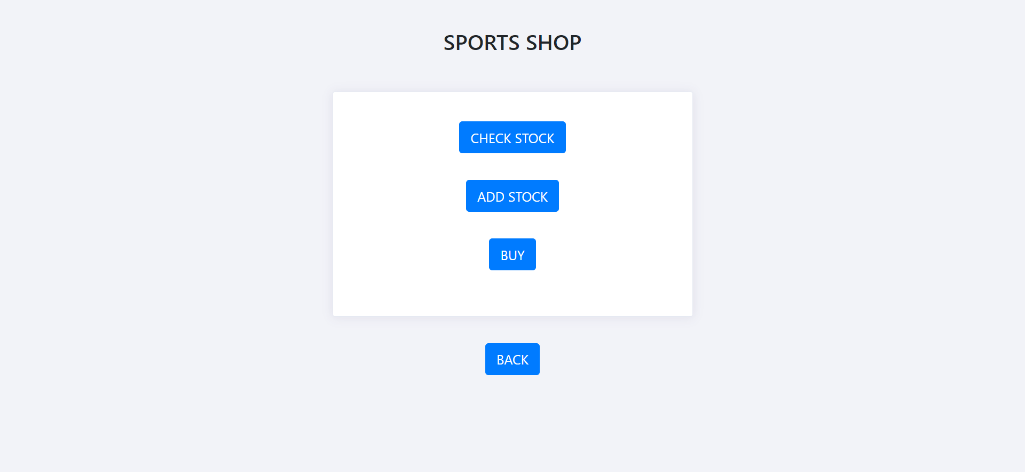

<?php

session_start();

$dbhost = "localhost";

$dbuser = "root";

$dbpass = "";

$dbname = "sports";

if(!$con = mysqli_connect($dbhost,$dbuser,$dbpass,$dbname))

{

die("failed to connect!");

}

?>

<!DOCTYPE html>

<html>

<head>

<title>home</title>

<meta charset="utf-8">

<title>home</title>

<meta name="viewport" content="width=device-width, initial-scale=1">

<script src="https://code.jquery.com/jquery-1.10.2.min.js"></script>

<link href="https://cdn.jsdelivr.net/npm/bootstrap@4.1.1/dist/css/bootstrap.min.css" rel="stylesheet">

<script src="https://cdn.jsdelivr.net/npm/bootstrap@4.1.1/dist/js/bootstrap.bundle.min.js"></script>

</head>

<body>

<div class="container h-100">

<div class="row h-100">

<div class="col-sm-10 col-md-8 col-lg-6 mx-auto d-table h-100">

<div class="d-table-cell align-middle">

<div class="text-center mt-4">

<h1 class="h2">SPORTS SHOP</h1>

<br><br>

</div>

<div class="card">

<div class="card-body">

<div class="m-sm-4">

<form method="post">

<div class="text-center mt-3">

<button type="button" class="btn btn-lg btn-primary" onclick="location.href='detailsstock.php'">CHECK STOCK</button> <br><br>

</div>

<div class="text-center mt-3">

<button type="button" class="btn btn-lg btn-primary" onclick="location.href='addstock.php'">ADD STOCK</button> <br><br>

</div>

<div class="text-center mt-3">

<button type="button" class="btn btn-lg btn-primary" onclick="location.href='buy.php'">BUY</button> <br><br>

</div>

</form>

</div>

</div>

</div>

</div>

</div>

</div>

</div>

<div class="text-center mt-3">

<button type="button" class="btn btn-lg btn-primary" onclick="location.href='login.php'">BACK</button> <br><br>

</div>

<style type="text/css">

body{

margin-top:20px;

background-color: #f2f3f8;

}

.card {

margin-bottom: 1.5rem;

box-shadow: 0 1px 15px 1px rgba(52,40,104,.08);

}

.card {

position: relative;

display: -ms-flexbox;

display: flex;

-ms-flex-direction: column;

flex-direction: column;

min-width: 0;

word-wrap: break-word;

background-color: #fff;

background-clip: border-box;

border: 1px solid #e5e9f2;

border-radius: .2rem;

}

</style>

<script type="text/javascript">

</script>

</body>

</html>

**Stock table**

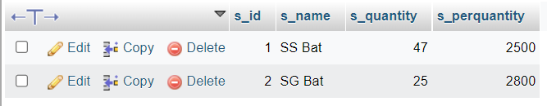

**Addstock.php**

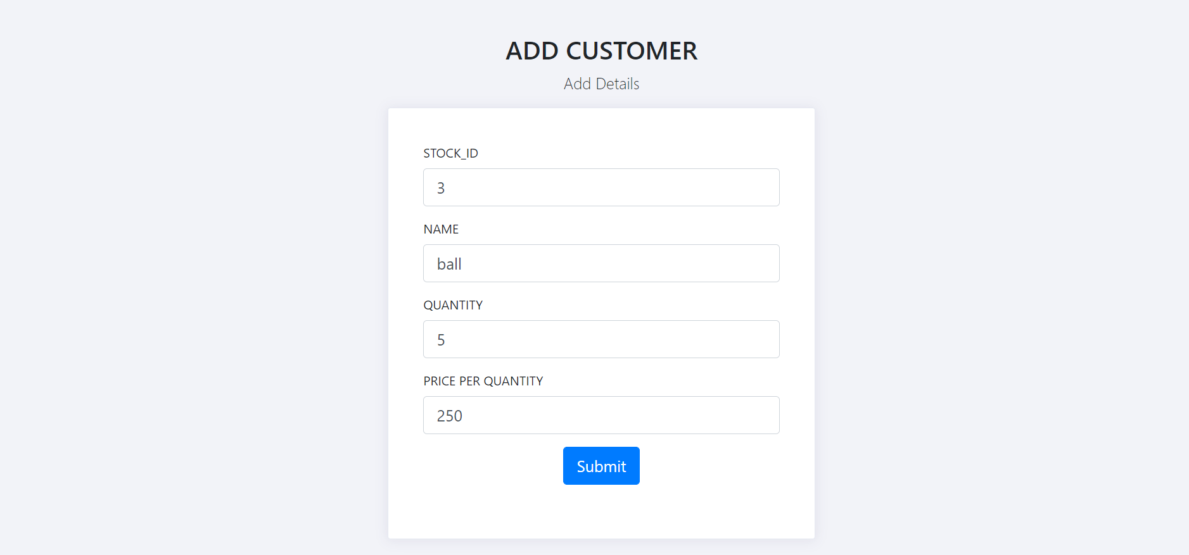

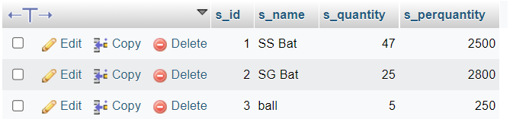

Html and css

<!DOCTYPE html>

<html lang="en">

<head>

<meta charset="utf-8">

<title>Registration</title>

<meta name="viewport" content="width=device-width, initial-scale=1">

<script src="https://code.jquery.com/jquery-1.10.2.min.js"></script>

<link href="https://cdn.jsdelivr.net/npm/bootstrap@4.1.1/dist/css/bootstrap.min.css" rel="stylesheet">

<script src="https://cdn.jsdelivr.net/npm/bootstrap@4.1.1/dist/js/bootstrap.bundle.min.js"></script>

</head>

<body>

<div class="container h-100">

<div class="row h-100">

<div class="col-sm-10 col-md-8 col-lg-6 mx-auto d-table h-100">

<div class="d-table-cell align-middle">

<div class="text-center mt-4">

<h1 class="h2">ADD CUSTOMER</h1>

<p class="lead">

Add Details

</p>

</div>

<div class="card">

<div class="card-body">

<div class="m-sm-4">

<form action="addstock1.php" method="post">

<div class="form-group">

<label>STOCK_ID</label>

<input class="form-control form-control-lg" type="number" name="s_id" placeholder="Enter stock id">

</div>

<div class="form-group">

<label>NAME</label>

<input class="form-control form-control-lg" type="text" name="s_name" placeholder="Enter name of stock">

</div>

<div class="form-group">

<label>QUANTITY</label>

<input class="form-control form-control-lg" type="number" name="s_quantity" placeholder="Enter quantity of stock">

</div>

<div class="form-group">

<label>PRICE PER QUANTITY</label>

<input class="form-control form-control-lg" type="number" name="s_perquantity" placeholder="Enter quantity of each product">

</div>

<div class="text-center mt-3">

<button type="submit" class="btn btn-lg btn-primary">Submit</button> <br><br>

</div>

</form>

</div>

</div>

</div>

</div>

</div>

</div>

</div>

<div class="text-center mt-3">

<button type="button" class="btn btn-lg btn-primary" onclick="location.href='viewstock.php'">BACK</button> <br><br>

</div>

<style type="text/css">

body{

margin-top:20px;

background-color: #f2f3f8;

}

.card {

margin-bottom: 1.5rem;

box-shadow: 0 1px 15px 1px rgba(52,40,104,.08);

}

.card {

position: relative;

display: -ms-flexbox;

display: flex;

-ms-flex-direction: column;

flex-direction: column;

min-width: 0;

word-wrap: break-word;

background-color: #fff;

background-clip: border-box;

border: 1px solid #e5e9f2;

border-radius: .2rem;

}

</style>

<script type="text/javascript">

</script>

</body>

</html>

Query connection

<?php

session_start();

$dbhost = "localhost";

$dbuser = "root";

$dbpass = "";

$dbname = "sports";

if(!$con = mysqli_connect($dbhost,$dbuser,$dbpass,$dbname))

{

die("failed to connect!");

}

if($_SERVER['REQUEST_METHOD'] == "POST")

{

$s_id = $_POST['s_id'];

$s_name = $_POST['s_name'];

$s_quantity = $_POST['s_quantity'];

$s_perquantity=$_POST['s_perquantity'];

if(!empty($s_name) && !empty($s_quantity)&& !empty($s_id) && !empty($s_perquantity))

{

$query = "insert into stock (s_id,s_name,s_quantity,s_perquantity ) VALUES ('$s_id','$s_name', '$s_quantity','$s_perquantity')";

mysqli_query($con, $query);

}else

{

echo "Please enter some valid information!";

header("Location: viewstock.php");

}

}

mysqli_close($con);

header("Location: viewstock.php");

?>

**Detailsstock.php**

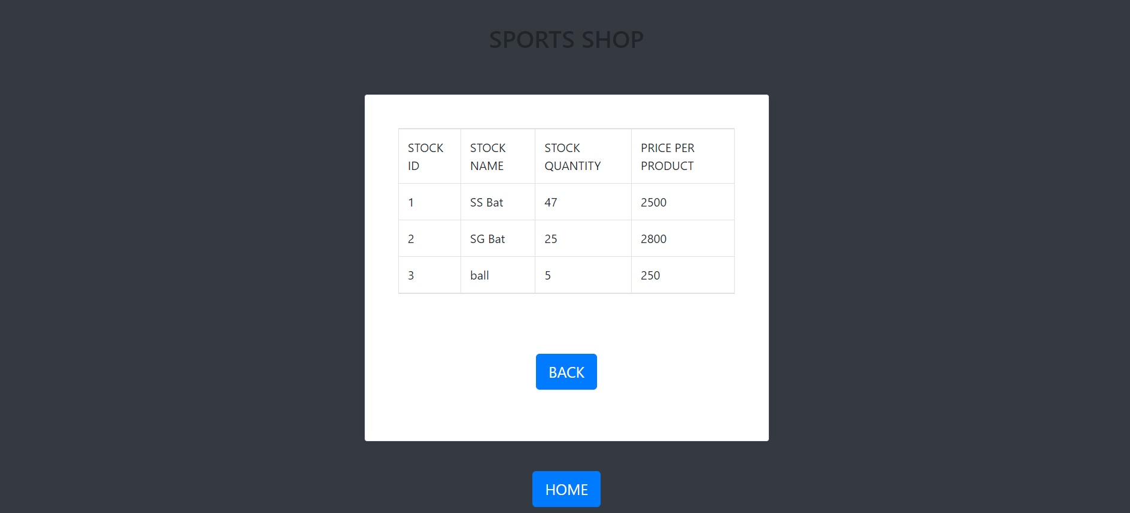

<?php

require_once("connection.php");

$query = " select * from stock ";

$result = mysqli_query($con,$query);

?>

<!DOCTYPE html>

<html lang="en">

<head>

<meta name="viewport" content="width=device-width, initial-scale=1">

<script src="https://code.jquery.com/jquery-1.10.2.min.js"></script>

<link href="https://cdn.jsdelivr.net/npm/bootstrap@4.1.1/dist/css/bootstrap.min.css" rel="stylesheet">

<script src="https://cdn.jsdelivr.net/npm/bootstrap@4.1.1/dist/js/bootstrap.bundle.min.js"></script>

</head>

<body class="bg-dark">

<div class="container h-100">

<div class="row h-100">

<div class="col-sm-10 col-md-8 col-lg-6 mx-auto d-table h-100">

<div class="d-table-cell align-middle">

<div class="text-center mt-4">

<h1 class="h2">SPORTS SHOP</h1>

<br><br>

</div>

<div class="card">

<div class="card-body">

<div class="m-sm-4">

<table class="table table-bordered">

<tr>

<td> STOCK ID </td>

<td> STOCK NAME</td>

<td> STOCK QUANTITY </td>

<td> PRICE PER PRODUCT</td>

</tr>

<?php

while($row=mysqli_fetch_assoc($result))

{

$s_id = $row['s_id'];

$s_name = $row['s_name'];

$s_quantity = $row['s_quantity'];

$s_perquantity = $row['s_perquantity'];

?>

<tr>

<td><?php echo $s_id ?></td>

<td><?php echo $s_name ?></td>

<td><?php echo $s_quantity ?></td>

<td><?php echo $s_perquantity ?></td>

</tr>

<?php

}

?>

</table>

<br><br>

<div class="text-center mt-3">

<button type="button" class="btn btn-lg btn-primary" onclick="location.href='viewstock.php'">BACK</button> <br><br>

</div>

</div>

</div>

</div>

</div>

</div>

</div>

</div>

<div class="text-center mt-3">

<button type="button" class="btn btn-lg btn-primary" onclick="location.href='login.php'">HOME</button> <br><br>

</div>

<style type="text/css">

body{

margin-top:20px;

background-color: #f2f3f8;

}

.card {

margin-bottom: 1.5rem;

box-shadow: 0 1px 15px 1px rgba(52,40,104,.08);

}

.card {

position: relative;

display: -ms-flexbox;

display: flex;

-ms-flex-direction: column;

flex-direction: column;

min-width: 0;

word-wrap: break-word;

background-color: #fff;

background-clip: border-box;

border: 1px solid #e5e9f2;

border-radius: .2rem;

}

</style>

<script type="text/javascript">

</script>

</body>

</html>

**Buy.php**

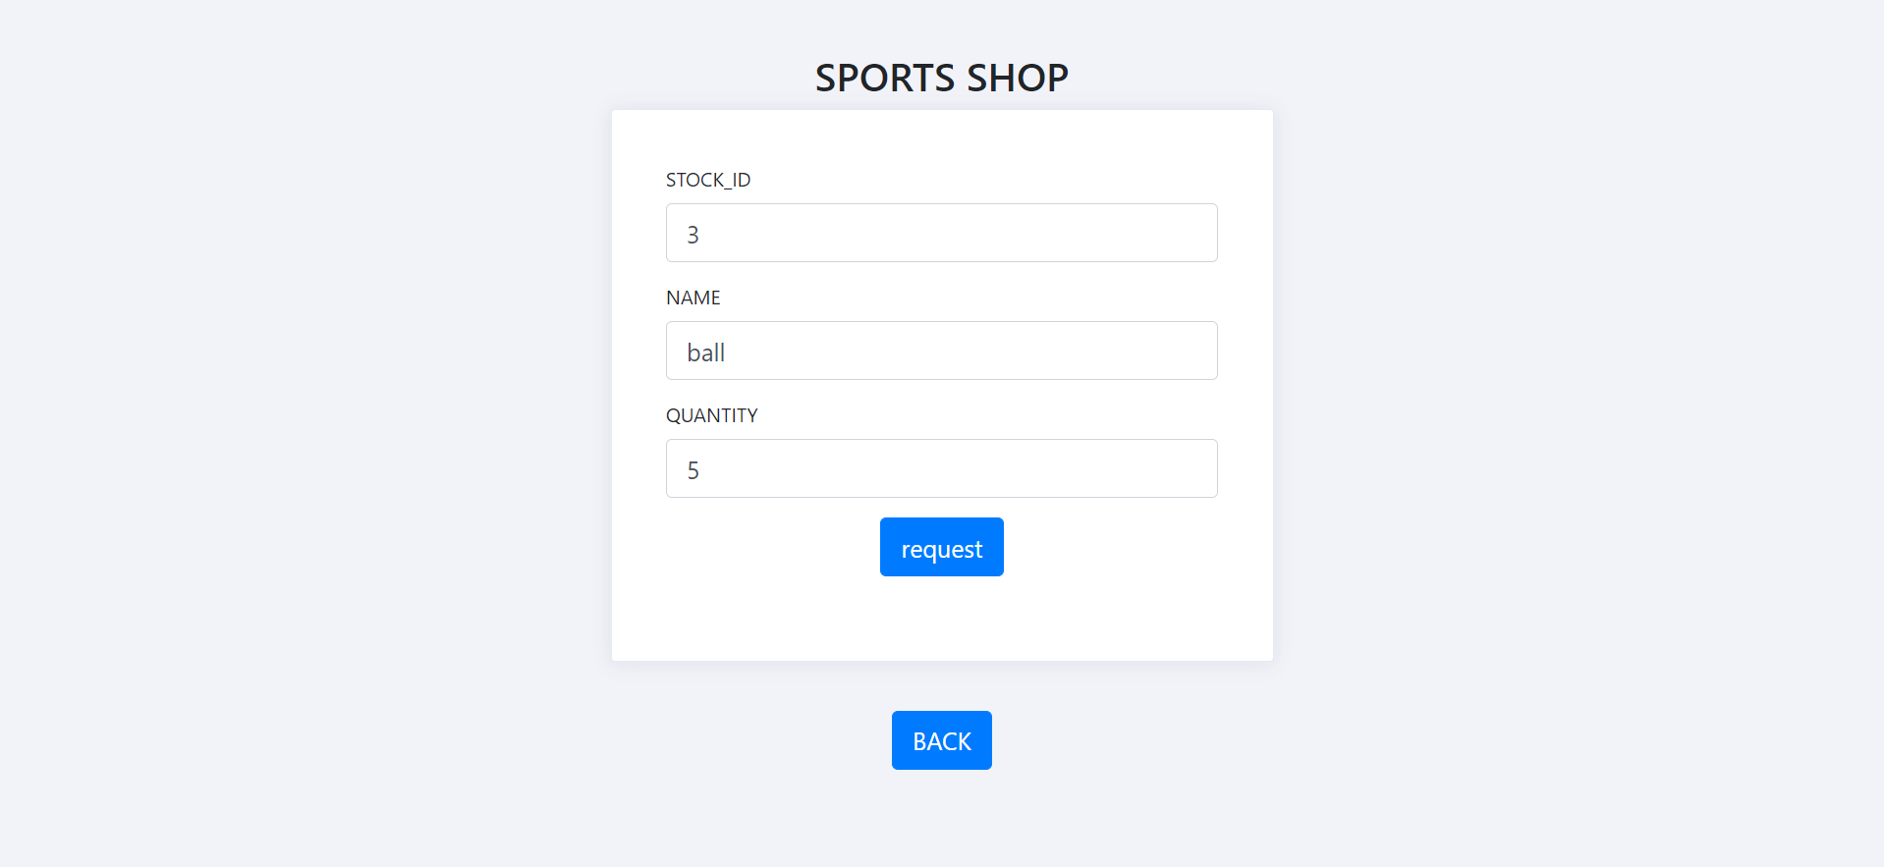

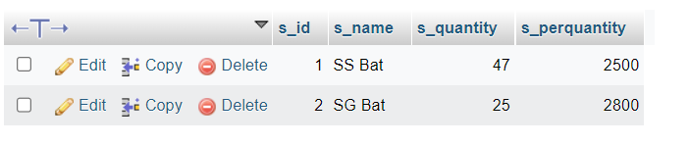

Html and css

<!DOCTYPE html>

<html lang="en">

<head>

<meta charset="utf-8">

<title>request</title>

<meta name="viewport" content="width=device-width, initial-scale=1">

<script src="https://code.jquery.com/jquery-1.10.2.min.js"></script>

<link href="https://cdn.jsdelivr.net/npm/bootstrap@4.1.1/dist/css/bootstrap.min.css" rel="stylesheet">

<script src="https://cdn.jsdelivr.net/npm/bootstrap@4.1.1/dist/js/bootstrap.bundle.min.js"></script>

</head>

<body>

<div class="container h-100">

<div class="row h-100">

<div class="col-sm-10 col-md-8 col-lg-6 mx-auto d-table h-100">

<div class="d-table-cell align-middle">

<div class="text-center mt-4">

<h1 class="h2">SPORTS SHOP</h1>

</div>

<div class="card">

<div class="card-body">

<div class="m-sm-4">

<form action="buy1.php" method="post">

<div class="form-group">

<label>STOCK_ID</label>

<input class="form-control form-control-lg" type="number" name="s_id" placeholder="Enter stock id">

</div>

<div class="form-group">

<label>NAME</label>

<input class="form-control form-control-lg" type="text" name="s_name" placeholder="Enter stock name">

</div>

<div class="form-group">

<label>QUANTITY</label>

<input class="form-control form-control-lg" type="number" name="quantity" placeholder="Enter your quantity">

</div>

<div class="text-center mt-3">

<button type="submit" class="btn btn-lg btn-primary">request</button> <br><br>

</div>

</form>

</div>

</div>

</div>

</div>

</div>

</div>

</div>

<div class="text-center mt-3">

<button type="button" class="btn btn-lg btn-primary" onclick="location.href='viewstock.php'">BACK</button> <br><br>

</div>

<style type="text/css">

body{

margin-top:20px;

background-color: #f2f3f8;

}

.card {

margin-bottom: 1.5rem;

box-shadow: 0 1px 15px 1px rgba(52,40,104,.08);

}

.card {

position: relative;

display: -ms-flexbox;

display: flex;

-ms-flex-direction: column;

flex-direction: column;

min-width: 0;

word-wrap: break-word;

background-color: #fff;

background-clip: border-box;

border: 1px solid #e5e9f2;

border-radius: .2rem;

}

</style>

<script type="text/javascript">

</script>

</body>

</html>

Querry connection

<?php

session_start();

$dbhost = "localhost";

$dbuser = "root";

$dbpass = "";

$dbname = "sports";

if(!$con = mysqli_connect($dbhost,$dbuser,$dbpass,$dbname))

{

die("failed to connect!");

}

$resquantity=$_POST['quantity'];

$resname=$_POST['s_name'];

$ressid=$_POST['s_id'];

$query= "SELECT * FROM stock where s_id ='".$ressid."' ";

$result = mysqli_query($con,$query);

$row=mysqli_fetch_assoc($result);

$s_quantity = $row['s_quantity'];

if($s_quantity>0 && $resquantity<=$s_quantity)

{

$s_quantity-=$resquantity;

//new

if($s_quantity==0)

{

**$query = "delete from stock where s_id='".$ressid."'";**

mysqli_query($con, $query);

}

else

{

**$query = "UPDATE stock SET s_quantity='".$s_quantity."' where s_id='".$ressid."'";**

mysqli_query($con, $query);

}

$x=$row['s_perquantity'];

$p=$x*$resquantity;

$query1 ="insert into buy (b_price) VALUES ('$p')";

$result1 = mysqli_query($con,$query1);

header("Location: bill.php");

}

else{

echo "no stock currently available!";

header("Location: buy.php");

}

mysqli_close($con);

?>

**Bill.php**

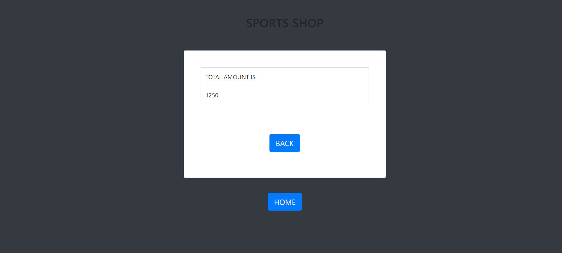

<?php

require_once("connection.php");

$query = " select * from buy order by buy_id desc limit 1 ";

$result = mysqli_query($con,$query);

?>

<!DOCTYPE html>

<html lang="en">

<head>

<meta name="viewport" content="width=device-width, initial-scale=1">

<script src="https://code.jquery.com/jquery-1.10.2.min.js"></script>

<link href="https://cdn.jsdelivr.net/npm/bootstrap@4.1.1/dist/css/bootstrap.min.css" rel="stylesheet">

<script src="https://cdn.jsdelivr.net/npm/bootstrap@4.1.1/dist/js/bootstrap.bundle.min.js"></script>

</head>

<body class="bg-dark">

<div class="container h-100">

<div class="row h-100">

<div class="col-sm-10 col-md-8 col-lg-6 mx-auto d-table h-100">

<div class="d-table-cell align-middle">

<div class="text-center mt-4">

<h1 class="h2">SPORTS SHOP</h1>

<br><br>

</div>

<div class="card">

<div class="card-body">

<div class="m-sm-4">

<table class="table table-bordered">

<tr>

<td> TOTAL AMOUNT IS </td>

</tr>

<?php

while($row=mysqli_fetch_assoc($result))

{

$b_price = $row['b_price'];

?>

<tr>

<td><?php echo $b_price ?></td>

</tr>

<?php

}

?>

</table>

<br><br>

<div class="text-center mt-3">

<button type="button" class="btn btn-lg btn-primary" onclick="location.href='viewstock.php'">BACK</button> <br><br>

</div>

</div>

</div>

</div>

</div>

</div>

</div>

</div>

<div class="text-center mt-3">

<button type="button" class="btn btn-lg btn-primary" onclick="location.href='login.php'">HOME</button> <br><br>

</div>

<style type="text/css">

body{

margin-top:20px;

background-color: #f2f3f8;

}

.card {

margin-bottom: 1.5rem;

box-shadow: 0 1px 15px 1px rgba(52,40,104,.08);

}

.card {

position: relative;

display: -ms-flexbox;

display: flex;

-ms-flex-direction: column;

flex-direction: column;

min-width: 0;

word-wrap: break-word;

background-color: #fff;

background-clip: border-box;

border: 1px solid #e5e9f2;

border-radius: .2rem;

}

</style>

<script type="text/javascript">

</script>

</body>

</html>

Connection.php

<?php

$dbhost = "localhost";

$dbuser = "root";

$dbpass = "";

$dbname = "sports";

if(!$con = mysqli_connect($dbhost,$dbuser,$dbpass,$dbname))

{die("failed to connect!");

}

?>

**Buy table**

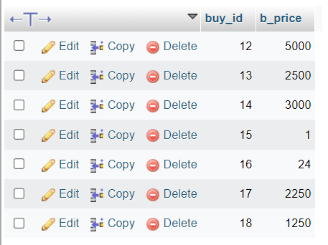

**Logout.php**

<?php

session_start();

header("Location: home.php");

die;

?>

**.xml**

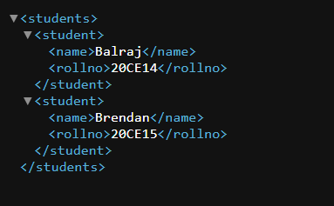

<?xml version="1.0"?>

<students>

<student>

<name>Balraj</name>

<rollno>20CE14</rollno>

</student>

<student>

<name>Brendan</name>

<rollno>20CE15</rollno>

</student>

</students>

Questions

1. Explain the neccesity of HTML/CSS in your project?

Ans. HTML/CSS was used to design the front end of the Sports Shop Management System.

2. Explain the neccesity of Java Script in your project?

Ans. Java Script was used to perform the relevant validations in the project.

3. Explain the neccesity of php in your project?

Ans.PHP was used to connect the front end and back end of the project.

4. Explain the neccesity of MySQL in the project?

Ans. MySQL was used to store the customer,employee,product details which were entered through the front end.

5. Explain the neccesity of XML in your project ?

Ans.XML was used to display the About-Me details i.e Rollno and Name.